Selfless: Paul’s Letter to the Romans
Romans 15:14-33– page 949
Paul has made some bold challenges and reminders throughout the letter. Today, Paul begins to draw his letter to a close with some personal challenges of how to live in response to the gospel.
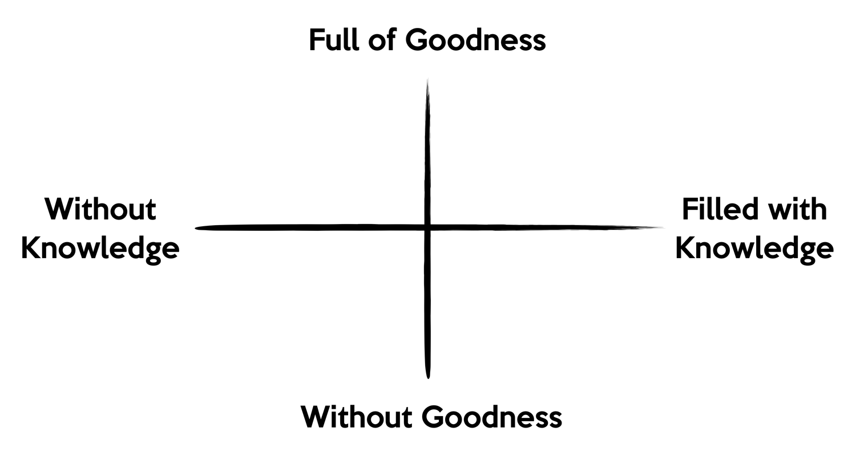
In response to the Gospel:
Pursue a Transformed Life to bring Transformation (15:14-16)

Invest in God’s Work (15:17-21)

Pursue Generosity (15:22-29)

Strive Together in Prayer (15:30-33)

Reflection and Action:

- Set a point on the transformation grid for yourself. Where would others set your point?

- How are you actively participating in God's transforming work in the world?

