Framework: What is a Godly Worldview?
God’s Grace – Genesis 3
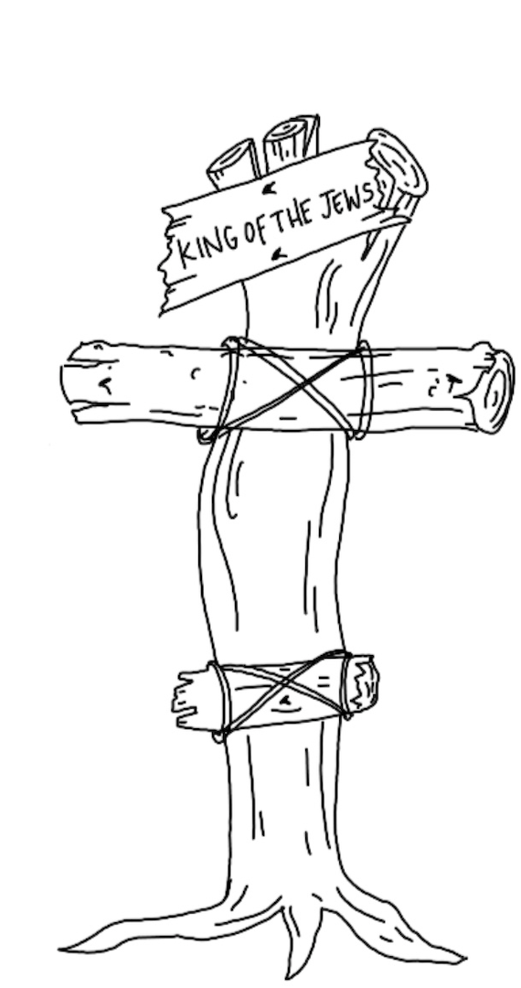
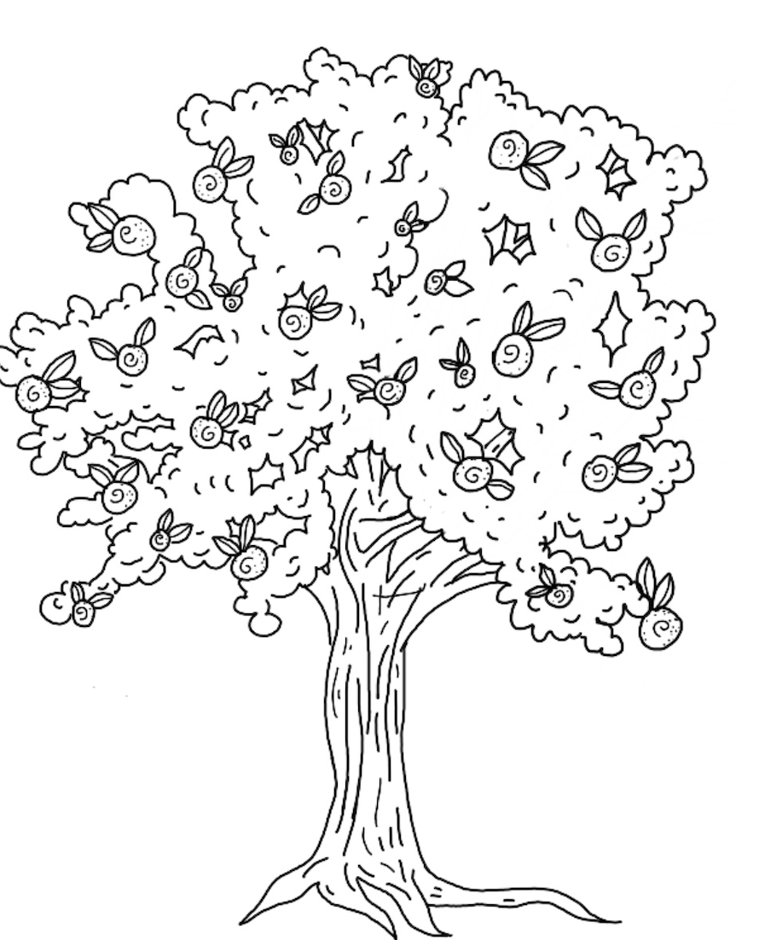
A worldview is a framework from which we view reality and make sense of the world. A biblical worldview is understanding God’s story through the lens of Creation, Fall, Redemption and Restoration. Our lives and world are broken because of the consequences of a choice that took place at a tree. Our lives and the world can be different because of the grace demonstrated at another tree.

1 Peter 2:24
Genesis 2-3

For Discussion:
  - How does God’s view of sin impact how you think about yourself and others?
  - Is there a sin in your life that you are in denial about, too proud to admit, too stubborn to give up?

